Practical No 20 & 21

VIII. Resources required (Additional)
→ If any web resources required.

Resources used (Additional)
https://www.tutorialspoint.com/vb.net/vb.net

Program Code
  - Write a program to implement the concept of method overloading & overriding.
- Overloading:
Module Module1

Sub Main()
Dim res As New addition
Console.WriteLine("Overloaded Values of Class addition") Console.WriteLine(res.add(10)) Console.WriteLine(res.add(35, 20))
Console.ReadLine() End Sub

End Module

Public Class addition Public i, j As Integer
Public Function add(ByVal i As Integer) As Integer Return i
End Function

Public Function add(ByVal i As Integer, ByVal j As Integer) As Integer Return i + j
End Function End Class

Output:
Overloaded Values of Class addition 10
55

Overriding:
Module Module1

Sub Main()
Dim obj As New child Dim result As Integer result = obj.add(10, 5)
Console.WriteLine("Overloaded Values of Class addition") Console.WriteLine("Result =" & result) Console.ReadLine()
End Sub End Module
Public Class parent
Public Overridable Function add(ByVal i As Integer, ByVal j As Integer) Return (i + j)
End Function End Class

Public Class child Inherits parent
Public Overrides Function add(ByVal i As Integer, ByVal j As Integer) Console.WriteLine("Result of Addition =" & MyBase.add(12, 18)) Return (i + j)
End Function End Class

Output:

Result of Addition =30
Overloaded Values of Class addition Result =15

- Results (output of the program)
In the above overloading example the same function add is called to perform different operations based on different arguments.
In the above overriding the parent class function add is overridden in the child class using the MyBase.add(12, 18) statement. So first the overridden value is displayed, then the value from child class is display.

Practical related Questions
  - Find output of following Code.
- Area of the Circle : 31.181246 Area of the Rectangle : 20

Implement windows application for employee details using overriding method.
- Module Module1

Sub Main()
Dim obj As New EmpInfo obj.ShowInfo() Console.ReadLine()
End Sub

End Module
Public Class EmpPersonalDetails Dim name As String
Dim address As String
Public Overridable Function ShowInfo() Console.WriteLine("Employee Name" & name) Console.WriteLine("Employee Address" & address)
End Function End Class
Public Class EmpInfo
Inherits EmpPersonalDetails Dim EmpId As Integer
Dim sallary As Integer Dim JoinDate As Date
Overloads Function ShowInfo() MyBase.ShowInfo() Console.WriteLine("Employee ID" & EmpId)
Console.WriteLine("Employee Sallary" & sallary) Console.WriteLine("Employee Joining Date" & JoinDate)
End Function End Class
OUTPUT:

Employee Name Employee Address Employee ID0 Employee Sallary0
Employee Joining Date12:00:00 AM

- Exercise
  - Implement a windows application for show string concatenation using overload method
➢
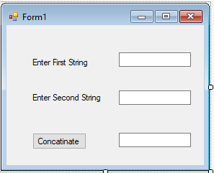

Public Class Form1

Private Sub Button1_Click(sender As Object, e As EventArgs) Handles Button1.Click Dim str1, str2, str3 As String
str1 = TextBox1.Text str2 = TextBox2.Text

str3 = str1 + str2 TextBox3.Text = str3
End Sub

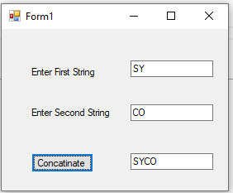
End Class
Output:

